Module Name: Login – Username Length Validation
Test Case ID: SD_TC_001
Scenario ID: EP-01
Technique: Equivalence Partitioning
Scenario: Enter a username with a length within the valid range and submit.
Test Input: Pruthvi10 (9 characters)
Expected Result: Accepted if the form enforces the stated 5–15 character rule.
Test Steps:
1. Open OrangeHRM login page
2. Enter username: Pruthvi10
3. Enter password: admin123
4. Click Login
Screenshots:
Step 1: Open OrangeHRM login page
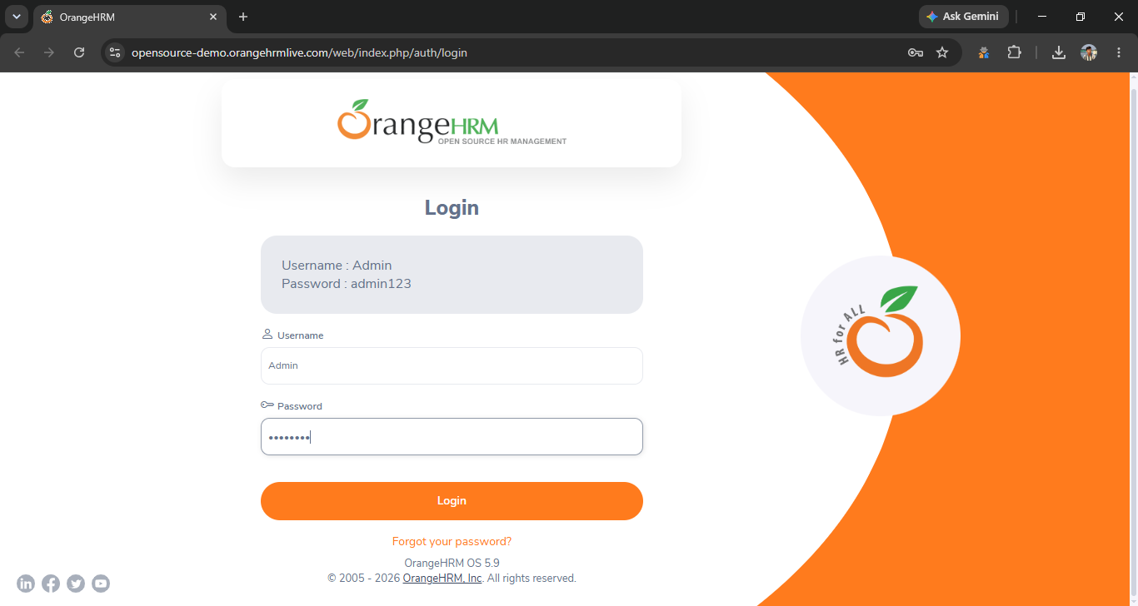Paste screenshot of Step 1 here
Step 2: Enter username: Pruthvi10
Paste scr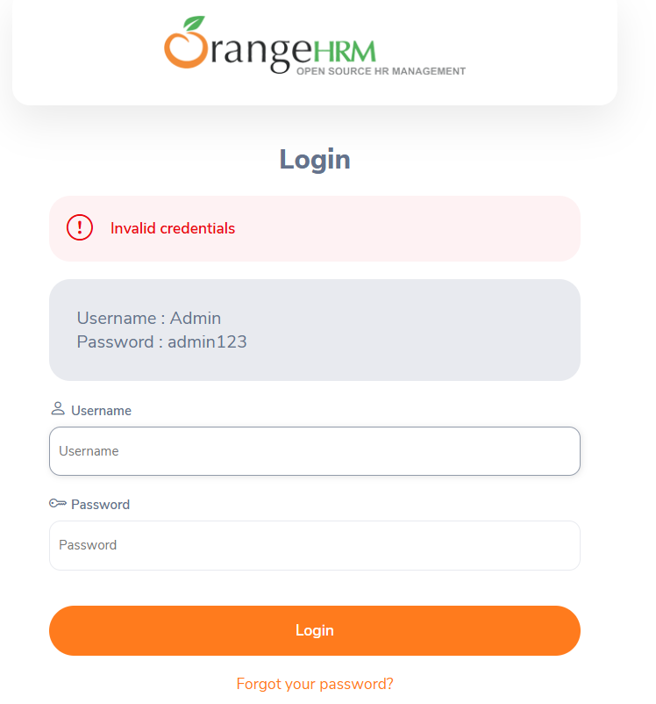eenshot of Step 2 here

Module Name: Login – Username Length Validation
Test Case ID: SD_TC_001
Scenario ID: EP-01
Technique: Equivalence Partitioning
Scenario: Enter a username with a length within the valid range and submit.
Test Input: Pruthvi10 (9 characters)
Expected Result: Accepted if the form enforces the stated 5–15 character rule.
Test Steps:
1. Open OrangeHRM login page
2. Enter username: Pruthvi10
3. Enter password: admin123
4. Click Login
Screenshots:
Step 1: Open OrangeHRM login page
Paste screenshot of Step 1 here
Step 2: Enter username: Pruthvi10
Paste screenshot of Step 2 here
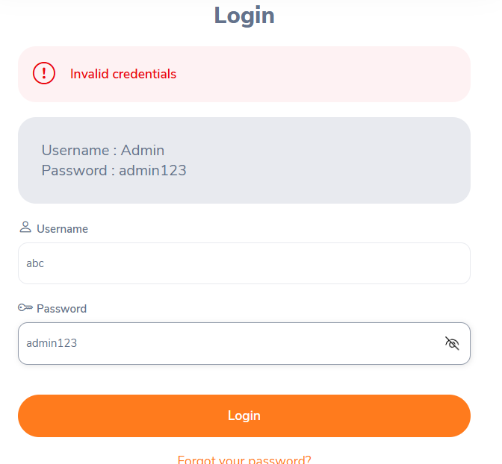Paste screenshot of Step 2 here

Actual Result: __fail__________________________
Status: Pass / Fail

Module Name: Login – Username Length Validation
Test Case ID: SD_TC_003
Scenario ID: EP-03
Technique: Equivalence Partitioning
Scenario: Enter a username longer than the maximum and submit.
Test Input: abcdefghijklmnop (16 characters)
Expected Result: Rejected with validation feedback.
Test Steps:
1. Open OrangeHRM login page
2. Enter username: abcdefghijklmnop
3. Enter password: admin123
4. Click Login
Screenshots:
Step 1: Open OrangeHRM login page
Paste screenshot of Step 1 here
Step 2: Enter username: abcdefghijklmnop
Enter password: admin123

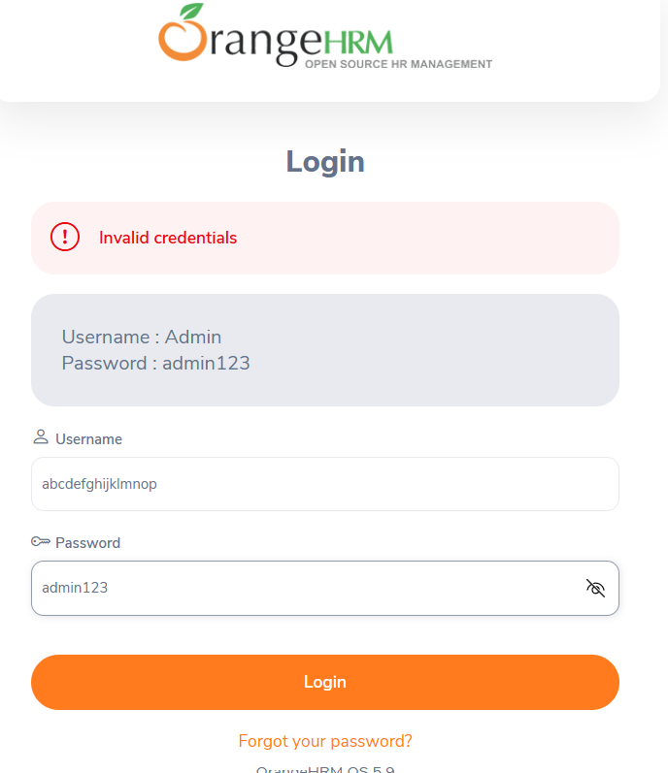Paste screenshot of Step 2 here

Actual Result: __________faill__________________
Status: Pass / Fail

Module Name: Login – Username Length Validation
Test Case ID: SD_TC_004
Scenario ID: BVA-01
Technique: Boundary Value Analysis
Scenario: Submit a username with 4 characters.
Test Input: abcd (4 characters)
Expected Result: Rejected; just below minimum.
Test Steps:
1. Open OrangeHRM login page
2. Enter username: abcd
3. Enter password: admin123
4. Click Login
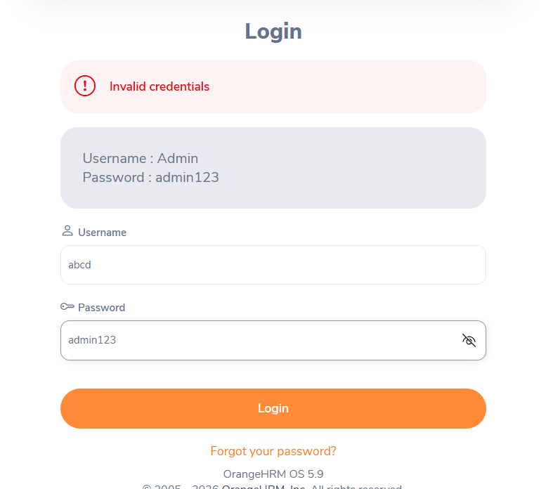Paste screenshot of Step 1 here
Screenshots:

Actual Result: ________faill____________________
Status: Pass / Fail

Module Name: Login – Username Length Validation
Technique: Boundary Value Analysis
Scenario: Submit a username with 5 characters.
Test Input: abcde (5 characters)
Expected Result: Accepted; minimum valid length.
Test Steps:
1. Open OrangeHRM login page
2. Enter username: abcde
3. Enter password: admin123
4. Click Login
Screenshots:
Step 1: Open Ora 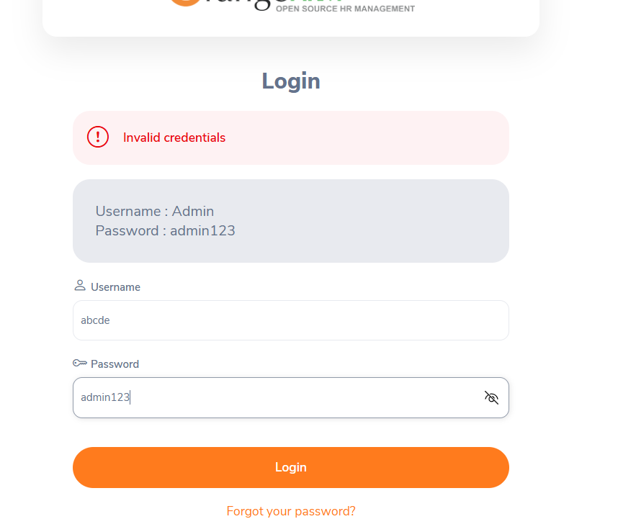ngeHRM login page

Actual Result: _____fail_______________________
Status: Pass / Fail

Module Name: Login – Username Length Validation
Test Case ID: SD_TC_006
Scenario ID: BVA-03
Technique: Boundary Value Analysis
Scenario: Submit a username with 6 characters.
Test Input: abcdef (6 characters)
Expected Result: Accepted; just above minimum.
Test Steps:
1. Open OrangeHRM login page
2. Enter username: abcdef
3. Enter password: admin123
4. Click Login
Screenshots:
Step 1: Open OrangeHRM login page
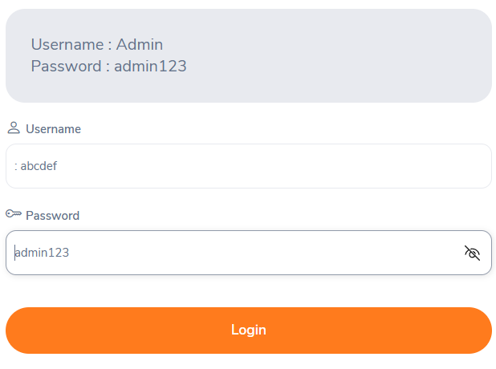Paste screenshot of Step 1 here

Actual Result: ___fail_____________________
Status: Pass / Fail

Module Name: Login – Username Length Validation
Test Case ID: SD_TC_007
Scenario ID: BVA-04
Technique: Boundary Value Analysis
Scenario: Submit a username with 14 characters.
Test Input: abcdefghijklmn (14 characters)
Expected Result: Accepted; just below maximum.
Test Steps:
1. Open OrangeHRM login page
2. Enter username: abcdefghijklmn
3. Enter password: admin123
4. Click Login
Screenshots:
Step 1: Open OrangeHRM login page
Paste screens 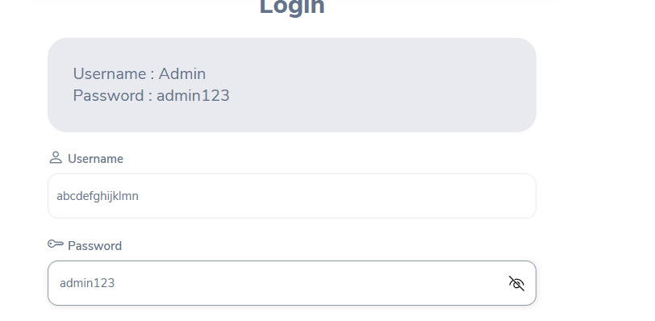hot of Step 1 here

Step 4: Click Login
Actual Result: ____________________________
Status: Pass / Fail

Module Name: Login – Username Length Validation
Test Case ID: SD_TC_008
Scenario ID: BVA-05
Technique: Boundary Value Analysis
Scenario: Submit a username with 15 characters.
Test Input: abcdefghijklmno (15 characters)
Expected Result: Accepted; maximum valid length.
Test Steps:
1. Open OrangeHRM login page
2. Enter username: abcdefghijklmno
3. Enter password: admin123
4. Click Login
Screenshots:
Step 1: Open OrangeHRM login page
Paste screensh 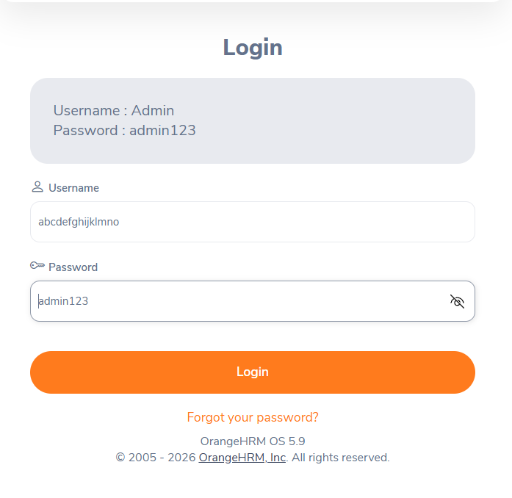ot of Step 1 here

Module Name: Login – Username Length Validation
Test Case ID: SD_TC_009
Scenario ID: BVA-06
Technique: Boundary Value Analysis
Scenario: Submit a username with 16 characters.
Test Input: abcdefghijklmnop (16 characters)
Expected Result: Rejected; just above maximum.
Test Steps:
1. Open OrangeHRM login page
2. Enter username: abcdefghijklmnop
3. Enter password: admin123
4. Click Login
Screenshots:
Step 1: Open OrangeHRM login page

Paste screenshot of Step 4 here
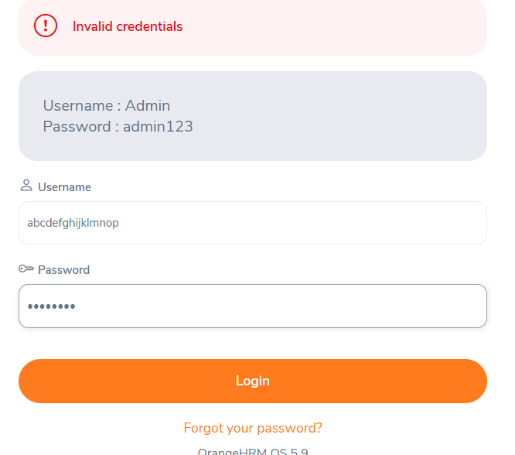
Actual Result: _____fail_______________________
Status: Pass / Fail

